

Group Project 2 - CDC Data on Obesity

Hannah Florimonte, Delenn Roelefs, Vinh Nguyen, Christian Gomez, Colby Harrison

California State University, Monterey Bay

BUS 468 - Business Analytics

Professor Sharma

May 8, 2021

# 

# 

# 

# 

# 

# 

# 

# 

# **INTRODUCTION**

Diving into the root of the epidemic of Obesity in the United States, we wanted to take a deeper look as to why this is occurring. Before we move forward, we want to define the term obesity and how it is calculated. According to the CDC, obesity is calculated by BMI. There are 3 classes of obesity, 30 to 35 BMI, 35 to 40 BMI, 40 BMI and up, this is known as severe obesity. This can be visualized by Figure 1. Right now, the average BMI is greater than 30, which is the entry point for obesity. Moreover, More often than not, the idea as to why we have an obesity epidemic is individual responsibility and people are obese through their own fault. These types of vacuous statements do not allow us to meaningfully find the root of the cause. According to the CDC, “the age-adjusted prevalence of obesity in adults was 42.4%, and there were no significant differences between men and women among all adults or by age group.” These are concerning numbers and they should be addressed. 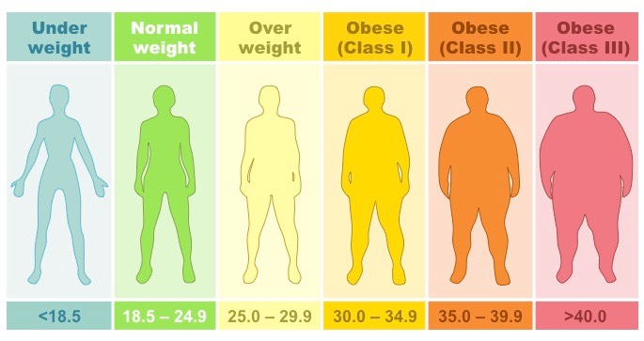

**Figure 1**

Why should we address this issue? It is unsustainable in various ways to have a growing obesity problem without addressing the root causes of it. Life expectancy, on average, is lowered by 3.3 years in both males and females (Peeters). Not to mention that Obesity is also a force amplifier for mortality later in life. (Peeters). Other debilitating health issues also arise from obesity, which are but not limited to type 2 diabetes, high blood pressure, heart disease and strokes. (NIH) Taking in only these medical issues, we see a myriad of significant problems the United States faces in the future if Obesity continues to grow. We have already seen what has happened during this pandemic. Obesity is a major factor in considering mortality among those who are at risk for Covid. In fact, according to Kaiser, the risk of death from Coronvirus is 10 times higher where most of the population is obese, compared to countries with less than half of obesity. Given that we had a high death toll per capita in the world the trend upward for obesity should concern us if there is ever another pandemic. Below is an example of underlying conditions in the world during the pandemic. Notice that Obesity is the 2nd leading with other lying conditions being related to obesity.

**

To put into context where we stand in the world, we are currently at the top of the chart when it comes to obesity percent of the population. In Figure 3 below, one can see that the US is 1st with Mexico 2nd. Now as stated before, people have different opinions as to why we have a rising obesity issue in the US. Our group believes that there is a link between socioeconomic status, and current weight. We believe these factors play a significant role in the current epidemic, as it will be stated in the hypothesis. Now as we move on, we feel it is important to reiterate that it is unsustainable for a country to ignore or barely do anything about the growing epidemic as there are significant consequences to a growing population, over time there will be major health and social issues regarding this so now is the best time to address the roots of the problem. In our data, which will later be introduced, the average age is 54 see Figure 4. Meaning this follows closely with the CDC data on obesity.

# 

**Figure 3**

# **Figure 4**

# **EXISTING MATERIALS AND LITERATURE**

There are a growing number of studies highlighting the correlation between obesity and lower socioeconomic status. For example, one study shows that those with low socioeconomic status have a higher probability of needing and utilizing medical services due to obesity-related disorders (Sonntag 2017). This study suggests that individuals with obesity require a higher cost-of-illness and therefore may require more attention and policy toward the implementation of obesity programs to solve this worldwide epidemic that is especially prevalent in the United States. Another study published in 2010 states that 17 percent of children and adolescents were obese in the United States, where childhood obesity often leads to adulthood (Ogden 2010). This same study also shows that obesity is greater in lower income populations. This author also shows the relationship between obesity in children among different racial group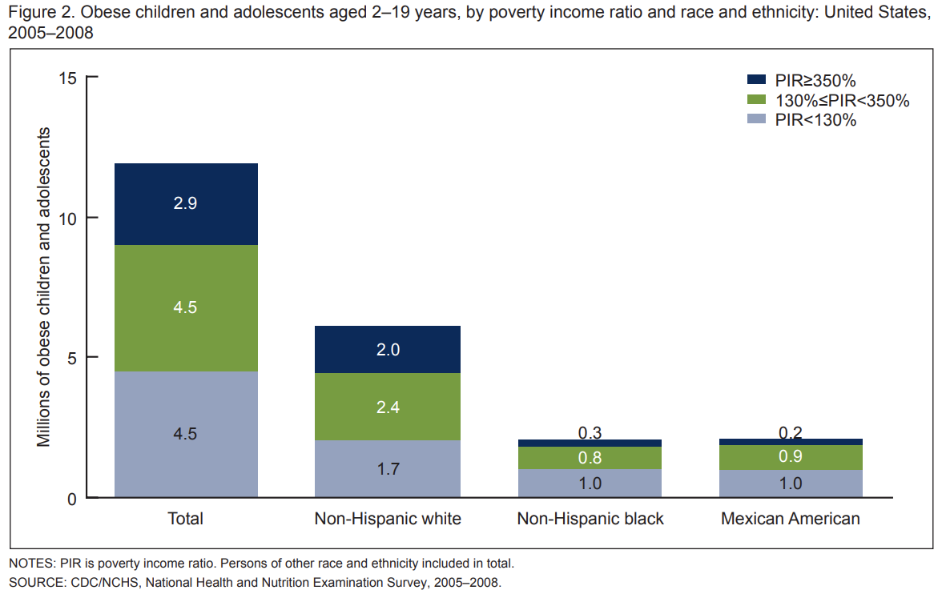

**Figure 5**

(Ogden 2010).

According to a National Health and Nutrition Examination Survey taken between 2005 and 2008, 38 percent of the 12 million obese adolescents live below 130 percent of the poverty level, meaning most obese children are not low income. This is an interesting finding as it does not suggest children raised in low-income households are more likely to be obese. On the other hand, this article presents that all boys and girls in highly educated households are less likely to become obese than children raised by guardians with less than a high school degree (Ogden 2010). This collection of data shows that there are several variables that may impact obesity in the United States either related to or outside of socioeconomic status that should be considered and taken seriously when implementing policy to correct these issues.

While these studies and research do show significant relationships between obesity and low socioeconomic status, obesity has shown to be a very complex disease and there is limited evidence on the direct correlation between obesity and socioeconomic status. Socioeconomic status can be broken down into several variables such as health, education, finance, and family-planning. This complexity requires more in-depth research regarding the several variables that may relate to an individual’s cause of obesity. Our research fulfills this gap because we have looked at extensive variables from our datasets which include information about age, weight, disease, income, education, eating habits, physical, and exercise routine. Given the additional variables to analyze, we have been able to create a larger picture including the various possibilities and leading factors that cause obesity, while still focusing on how they relate to socioeconomic status.

Understanding the relationship between obesity and socioeconomic status is a real issue that several real companies must research to run a successful business. In this case, the CDC’s main purpose is to save lives and protect people from health threats, conducting surveys and scientific research to release health information to protect our nation from the most dangerous health threats. As the United States is the leading nation with the highest obesity population in the world, the CDC has released this dataset with extensive data where we can compare obesity rates with differing educational statuses and income brackets. This data is significant for other companies as well, such as healthcare and obesity programs which would rely on such data in order to perform well. According to Sonntag, designing and implementing obesity programs requires commitment from multiple sectors including health, finance, education, and family planning, all of which could benefit from understanding the causes of obesity from datasets such as this one.

Our studies in particular highlight several variables that may be common leading factors contributing to obesity rates in the United States. By looking deeper into socioeconomic variables such as education, occupation, income, marital status, and more, we have created a more detailed story explaining how socioeconomic status relates to obesity and how each of these factors weigh differently. Our main research question we are trying to solve is fully understanding the relationship between weight and socioeconomic status, which will be discussed further in our hypothesis, where we will also explain the procedures taken to analyze our dataset.

# **HYPOTHESIS**

With the given data, the group wants to dive deeper into the impact of socio economics on the health of people. Depending on someone’s socioeconomic status, it can determine how it affects their weight. This can be dependent on variables such as accessible food, health information, medical accessibility, and income. These factors all vary depending on a person’s socioeconomic status.

The hypothesis being tested is that the lower the socioeconomic status, the higher the obesity rate is. This is caused by the lack of the same course of action. A person with higher socioeconomic options is more likely to access better food, better doctors and more alternatives to take care of their bodies and avoid obesity.

# ANALYSIS

The common thought that the higher the income a person has means the healthier and a lesser obesity rate people have compared to people with less income to be more obese. This is the hypothesis that we are testing with data from the CDC. We have selected two years to test, 2011 and 2015, which have more than an extensive amount of data as there are more than 440,000 individuals that participated in the survey for this data. These data sets have been collected through a various number of streams from landline and cell phone surveys to online surveys.

As our focus has been on how much a person makes will affect the BMI of a person, figures 6 and 7 below of the respective years 2011 and 2015 depict that our hypothesis of a person with higher socioeconomic status the lower the obesity rate. The graphs have two variables BMI, which is on a 0-4 scale, and income, which is sectioned from 1-8 of increasing incomes with 77 being a ‘Not sure’ option and 99 being a ‘Refused’ option. The column on the left is the frequency of how many people that have been surveyed answered into the respective columns.

As the income increases each level, the BMI per level shifts from a higher 4 rating to a 2-3 rating. The most drastic depiction of this is the 1st level and the 8th, respectively less than $10,000 and more than $75,000. The 1st level has the highest rate of obesity while the 8th level has a more acceptable rate of obesity. Slowly going through the different levels the change is more noticeable because not only are the rates changing but the frequencies of the income levels increase as well, showing the decrease in obesity to be more prevalent. Thus proving our main hypothesis to be true.

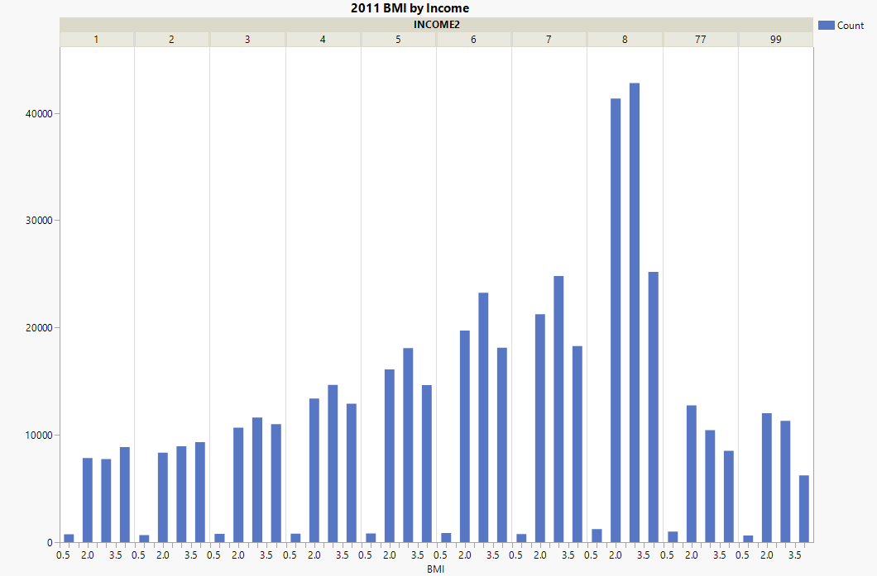

**Figure 6**

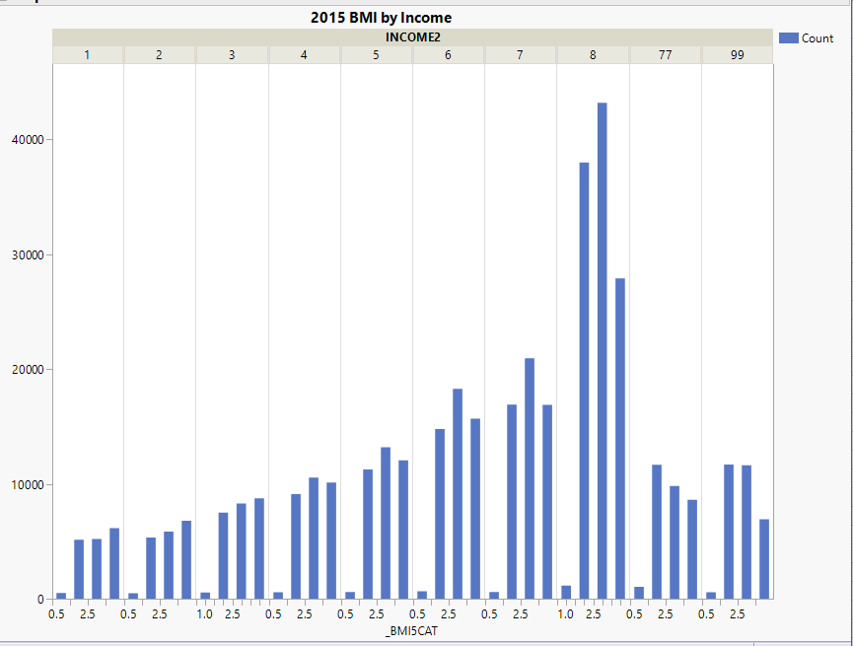

**Figure 7**

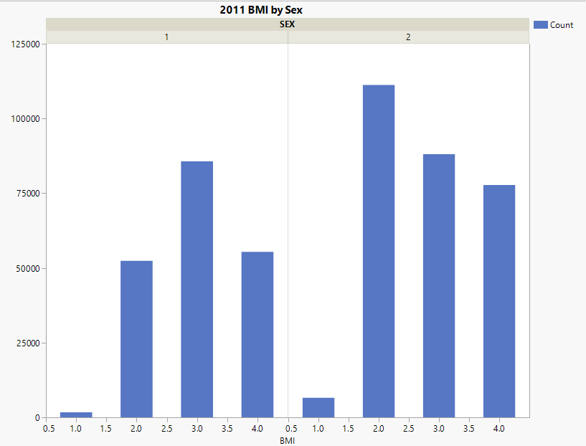

**Figure 8**

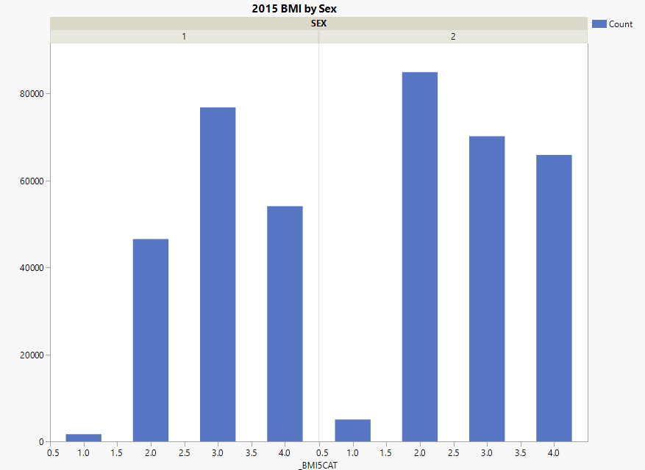

**Figure 9**

Above, Figure 8 and Figure 9 depict the BMI depending on sex. On the graph, it is separated by sex, level of obesity, and count. 1 represents male and 2 represents female on the top of the graph, while on the x axis, 1 represents underweight, 2 normal weight, 3 represents overweight, and 4 represents obese. When measuring male and female, females have a trend of higher obesity for both 2011 and 2015. In 2011, there were around 80,000 females who were obese while in 2015 there were around 75,000. This shows that females are more commonly obese than males overall, but the amount of females that were obese went down for the year 2015 compared to 2011. When looking at figure 8 as a whole and not focusing on just obesity ratings, females have a higher reporting of normal weights than males as well. Having around 115,000 compared to male’s 50,000, females have a significantly higher normal weight for 2011. Figure 9 depicts females having a higher number of normal weights as well compared to men, with slightly above 80,000 women being at a normal weight while men have around 45,000 at a normal weight.

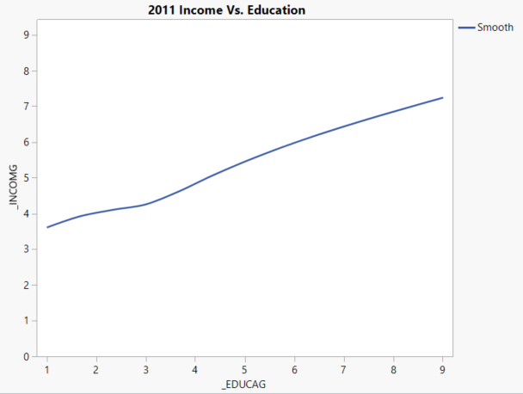

**Figure 10**

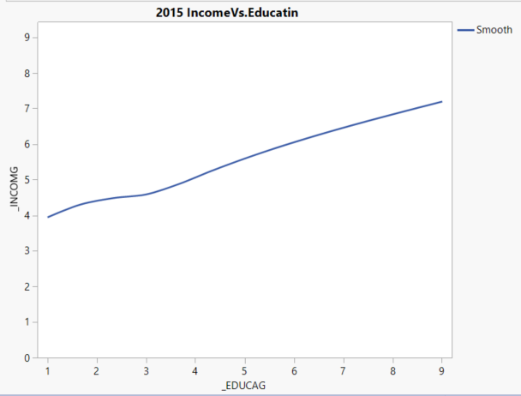

**Figure 11**

Based on the figures 10 and 11, it shows for both 2011 and 2015 the impact education has on income. By viewing these graphs, we can see that education allows people to have a higher income. And those with a higher income have a lower BMI, as seen on figure 6 and figure 7. If people have access to higher education, they will be more likely to lower the obesity rate. This is because of greater access to better healthcare, more nutritious foods, and other variables. By encouraging higher education and making it more available for those with lower socioeconomic circumstances, it is increasing the likelihood for a healthier weight, and decreasing the obesity rate.

**DISCUSSION & CONCLUSION**

There were limitations associated with the research that was done. One of the main limitations was that we did not have any medical history. This would have changed our findings and data significantly. Our findings are based on the data sets in which we used without medical data, and thus we were unable to exactly narrow down the cause of obesity.

# The United States comes in at the top of the charts when it comes to obesity percentage of the population. From Figure 3, the U.S. comes in at the top of the list followed by Mexico in 2015. Going into the research, our group focused on the cause and pattern between the data sets. There are studies which show the correlation between obesity and lower socioeconomic status being a factor. We were interested in seeing if the root cause of obesity was due to genetic or life choices for the population. Through our research of the data, we found the cause and effect between socioeconomic status of having a higher probability of needing and utilizing medical services due to obesity-related disorders. We were able to see how income and education affected the data in relation to the population size. Referring to figure 6 and 7, which showed the effects of socioeconomics and how it plays a role in our society.

# 

# **REFERENCES**

Adult obesity facts. (2021, February 11). Retrieved May 11, 2021, from https://www.cdc.gov/obesity/data/adult.html

Defining adult overweight & obesity. (2021, April 28). Retrieved May 11, 2021, from https://www.cdc.gov/obesity/adult/defining.html

Health risks of overweight & obesity. (n.d.). Retrieved May 11, 2021, from https://www.niddk.nih.gov/health-information/weight-management/adult-overweight-obesity/health-risks

MacDaragh Ryan, P., & Caplice, N. (2020, May 10). This is why people with obesity are more likely to die from coronavirus. Retrieved May 11, 2021, from https://www.weforum.org/agenda/2020/05/this-is-why-people-with-obesity-are-more-likely-to-die-from-coronavirus

Obesity is key driver of a Nation's COVID death toll, global study finds. (2021, March 05). Retrieved May 11, 2021, from <https://khn.org/morning-breakout/obesity-is-key-driver-of-a-nations-covid-death-toll-global-study-finds/>

Ogden, C., & National Center for Health Statistics. (2010). *Obesity and socioeconomic status in*

*children and adolescents: United States, 2005-2008* (NCHS data brief (Series) ; no. 51). Hyattsville, MD: U.S. Department of Health and Human Services, Centers for Disease Control and Prevention, National Center for Health Statistics.

Peeters, A., Barendregt, J. J., Willekens, F., Mackenbach, J. P., Mamun, A. A., Bonneux, L., & N. (2003, January 7). Obesity in adulthood and its consequences for life expectancy: A life-table analysis. Retrieved May 11, 2021, from <https://pubmed.ncbi.nlm.nih.gov/12513041/>

Sonntag, Diana, Jarczok, Marc N, & Ali, Shehzad. (2017). DC‐Obesity: A New Model for

Estimating Differential Lifetime Costs of Overweight and Obesity by Socioeconomic Status. *Obesity (Silver Spring, Md.),* *25*(9), 1603-1609.

Team, R. (2018, April 06). Sugar tax: Are Mexicans the fattest people in the world? Retrieved May 11, 2021, from https://www.bbc.com/news/world-43668927